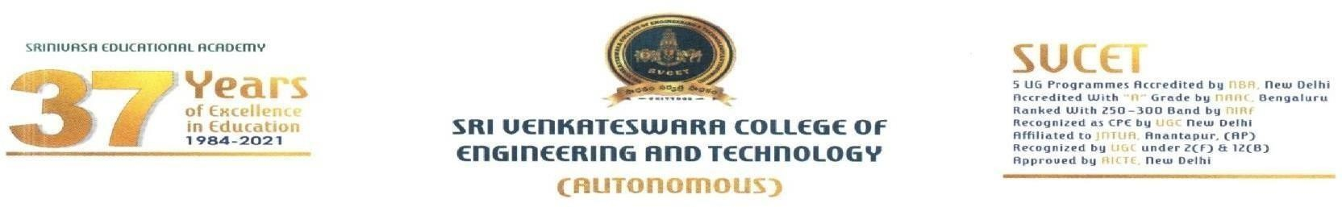
Name of the College: Date: 10/07/2026
Sri Venkateswara College of Engineering and Technology (Autonomous)
About College:
Sri Venkateswara College of Engineering & Technology (SVCET), Chittoor, established in the year 1998, enjoys the reputation as one of the best engineering colleges in Andhra Pradesh. The mission of the Institute is twofold – to educate and prepare students – as dynamic, competent, valued and knowledgeable professionals who shall lead the nation to reach the forefront of leadership in the field of engineering and technology.
SVCET is a self – financing autonomous professional college affiliated to Jawaharlal Nehru Technological University Anantapur, Anantapur, recognized by All India Council for Technical Education (AICTE), with 8 UG programs in Engineering & Technology accredited by National Board of Accreditation (NBA), New Delhi, Under Tier-I & Graded ‘A’ by National Assessment and Accreditation Council (NAAC), Bangalore. The college was ranked 176th in NIRF Ranking Frame work for the Year 2019-20, and was also accorded CPE(College with Potential for Excellence) status by UGC, New Delhi.
The College has spacious, well designed, adequately furnished and ventilated classrooms which provide ingenious ambience to the students for integrated learning practice. The College offers 14 undergraduate Engineering Programs in Civil, Mechanical, Electrical, Electronics, Computer Science, Computer Science (AI & ML), Computer Science (Data Science), Computer Science (Artificial Intelligence), B. Tech (Artificial Intelligence), Computer Science (AI & DS), Computer Science (Cyber Security), Computer Science (IoT), Computer Science (Business Systems) and Information Technology, along with Master’s Degree program in Computer Applications, Business Administration, M. Tech (VLSI Design) M. Tech (CAD/CAM), M. Tech (Computer Science & Engineering), M. Tech (Power Electronics and Electrical Drivers), &M. Tech (Data Science). The initiatives pursued by each and every department redesign the learning experience to make it more relevant, more effective, more efficient, and more reflective of individual learning styles.

Job Title:
Assistant Professor/Associate Professor/ Professor

Department:
Computer Science & Engineering (CSE), Information Technology (IT), Data Science (DS), Artificial Intelligence & Machine Learning (AI&ML), Internet of Things (IoT), Artificial Intelligence (AI) & Cyber Security (CS)
Qualification:

- Assistant Professor/ Associate Professor/ Professor - Ph. D Mandatory

Salary: As per UGC Norms (Additional perks for Research)

Apply Mode: Online application Eligibility of Candidature:

- Candidates with Prior experience and Freshers may also apply
- Candidates with good research experience and able to make frequent publications
- Proper relieving from the previous institution and ready to join immediately
- Candidates are required to carry all their original certificates. Salary in accordance with experience and qualifications.

How to apply: Forward your Resume/CV to Email hr@svcetedu.org
Website: www.svcetedu.org

Address:
The Principal,
Sri Venkateswara College of Engineering and Technology (Autonomous) RVS Nagar, Chittoor-517127.
Contact Number: +91-7729999151

PRINCIPAL
