Openings at BHARAT INSTITUTIONS
Hiring Organization: Bharat Institute of Engineering and Technology
Posting date: 18th July, 2026
Organization profile- Bharat Institutions, a distinguished institution affiliated with JNTU, Hyderabad, is situated in the serene environs of Ibrahimpatnam, Hyderabad. Located within the tranquil Mangalpally Village in the Ranga Reddy district, 25 kms away from Rajiv Gandhi International Airport, is offering an ideal setting for academic pursuits amidst nature's bounty. Bharat Institutions are committed to provide world class career oriented education and training. It is one of the phenomenal institutes in Telangana. Having accreditations such as NAAC, NBA, and ranking from NIRF. The institution aims to excel in teaching, industry orientation, research committed to provide excellent facilities to its faculty and ultramodern R & D facilities library enriched with national and international journals etc. Bharat Institutions welcomes you to a world of boundless possibilities.
JobTitle/Designation:Assistant Professor/Associate Professor/Professor for the departments of CSE, ECE, EEE, Mechanical,Civil,Maths, Chemistry,English,Physics and MBA.
Qualification: As per AICTE/JNTU norms. Looking for a faculty with passion, dedication and innovative teaching practices to enhance student skills who can meet the requirements of NIRF, NAAC, NBA.
Job Location:
- Mangalpally(Village), Ibrahimpatnam(mandal) Hyderabad, Rangareddy (dist)Telangana.
Pay Scale: As per AICTE Norms(Scale is not constraint for deserving candidate)
Apply Mode: Email
Organization website: www.biet.ac.in
How to Apply: Interested and Eligible candidates are informed to send their resumes based on their respective specializations to the below mentioned subject wise email addresses.
Email Address to Apply:

- For CSE-cse@biet.ac.in
- For ECE- ece25@biet.ac.in
-For EEE- eee@biet.ac.in
-For Civil- civiljobs@biet.ac.in
-ForMechanical- mechanicaljobs@biet.ac.in
- For Mathematics- mathsrect@biet.ac.in
-For Chemistry- chemistry@biet.ac.in
-For Physics- physics@biet.ac.in
-For English- english25@biet.ac.in
-For MBA- mba@biet.ac.in


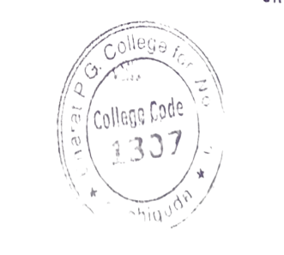

Authorized Person Signature
with seal (Mandatory)

