
VIVEKANANDHA COLLEGE OF NURSING
Affiliated to the Tamil Nadu Dr. M.G.R. Medical University,
Directorate of Medical Education, Chennai.
Sponsored by: Angammal Educational Trust
Elayampalayam,Tiruchengode,Namakkal Dt-637 205

Date: 09.07.2026
Faculty Recruitment 2026 job notification announced by Vivekanandha College of Nursing for women in Tiruchengode, Namakkal – Dt Tamilnadu, for 2026-2027 academic year. Eligible candidates are requested to apply through email.
Hiring Organization: Vivekanandha College of Nursing for women
Organization Profile: Vivekanandha College of Nursing has been established in the academic year 1993 and has been formally approved by the Government of Tamil Nadu. Our college of Nursing is affiliated to the Tamil Nadu Dr. M.G.R. Medical University, Chennai, School of Nursing is affiliated to Directorate of Medical Education, Chennai and School of ANM is affiliated to Directorate of Public Health & Preventive Medicine, Chennai. The college have been recognized by the Indian Nursing Council, New Delhi and the Tamil Nadu Nurses and Midwives Council. The College is roofed under “The Angammal Educational Trust”. We are hereby proud to say that the College has grown in leaps and bounds in such a short tenure. All the students have got placements after the completion of their course and many of the students have got placed in well reputed hospitals in the country and in abroad. The College has made a good forward walk to appear in the progressive and modern face in the Nursing arena. We have 32nd batch of B.Sc.Nursing and DGNM courses, 28th batch of M.Sc.Nursing, 15th batch of P.B.B.Sc.,(N) and 8th Batch of ANM Nursing.

I.Job Title/Designation: Wanted – Professor/Asst.Professor/Asso.Professor
Department have vacancies
- OBG (Nursing)
- Medical Surgical Nursing
- Pediatric Nursing
- Mental Health Nursing
Essential Qualification: M.Sc (Nursing) with Experience
Candidate Profile:
- Faculties should have fluency in English and good communication skills.
- Faculty who can successfully execute R&D and consultancy services will be preferred.
- Faculty who can promote Skill Development, Entrepreneurship Development, Industry Interaction, and other value-added courses will be preferred.
Job Location: Tiruchengode, Namakkal Dt., and Sankagiri, Salem Dt., Tamil Nadu
Pay Scale: As per College Norms
Apply Mode: Email (vcnw@vivekanandha.ac.in)
Organization website: www.vivekanadha.ac.in
Contact Address: Vivekanandha Educational Institutions, Elayampalayam, Tiruchengode - Tk, Namakkal - Dt, Tamilnadu - 637 205.

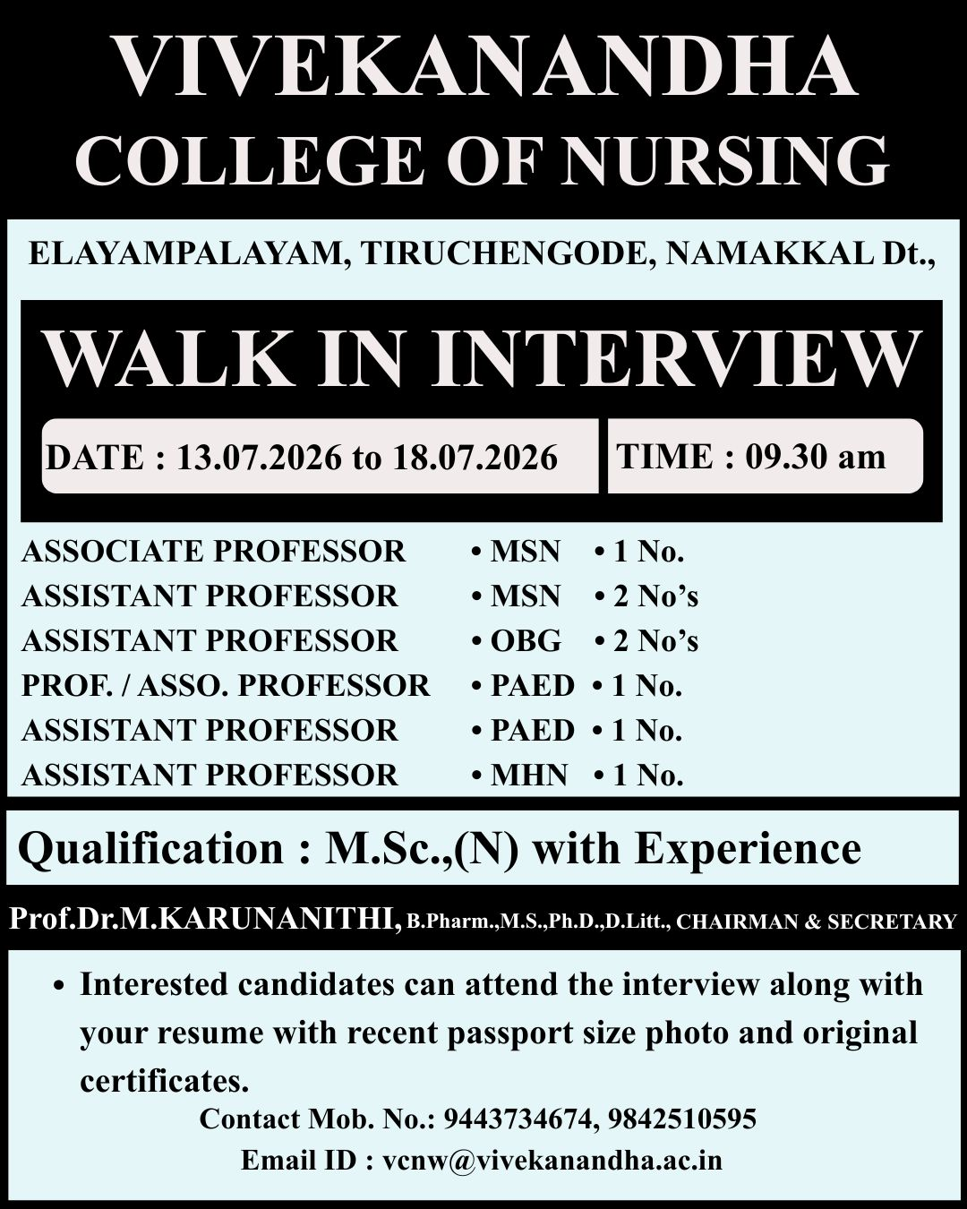

How to Apply: Interested and Eligible candidates are request to send resume through email - (vcnw@vivekanandha.ac.in)
Contact Number: 94437 34674, 94433 16521,

Principal/Authorized Signatory with seal

