An exciting teaching opportunity has been announced by Dhanalakshmi Srinivasan College of Engineering (Autonomous), Coimbatore ( DSCE-CBE) for the academic year 2026. The institution is inviting applications from qualified and passionate candidates for the positions of Assistant Professor across core engineering and allied disciplines. Interested candidates with relevant qualifications are encouraged to apply through email or postal mode before the specified deadline.

Post Date: 07.07.2026

Hiring Organisation: Dhanalakshmi Srinivasan College of Engineering, Coimbatore

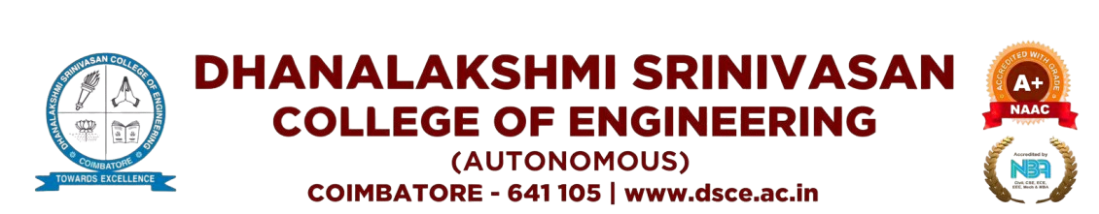

About College: Dhanalakshmi Srinivasan College of Engineering ,Coimbatore (DSCE-CBE) strives to establish itself as a citadel of quality technical education in the global arena of engineering and technological education. The college actively updates itself with foresight, vision and perspective of committed learning, research and training to meet the global demands for professional talents of international standards

Job Title:
- Assistant Professor

Department:
- English
- Mathematics

Qualification: M.A/ M.Sc/ Ph.D/ NET/ SET
Job Location: Coimbatore, Tamilnadu
Salary: As per norms
Apply Mode: Email/ Post
Website: www.dsce.ac.in
How to Apply: Interested Candidates can Send their Resume to the mail id along with the necessary relevant Documents on or before 12.07.2026.
Email Address to Apply: hr@dsce.ac.in
Postal Address:
Dhanalakshmi Srinivasan College of Engineering,
NH-47 Palakkad Main Road,
Navakkarai Post,
Coimbatore -641105

