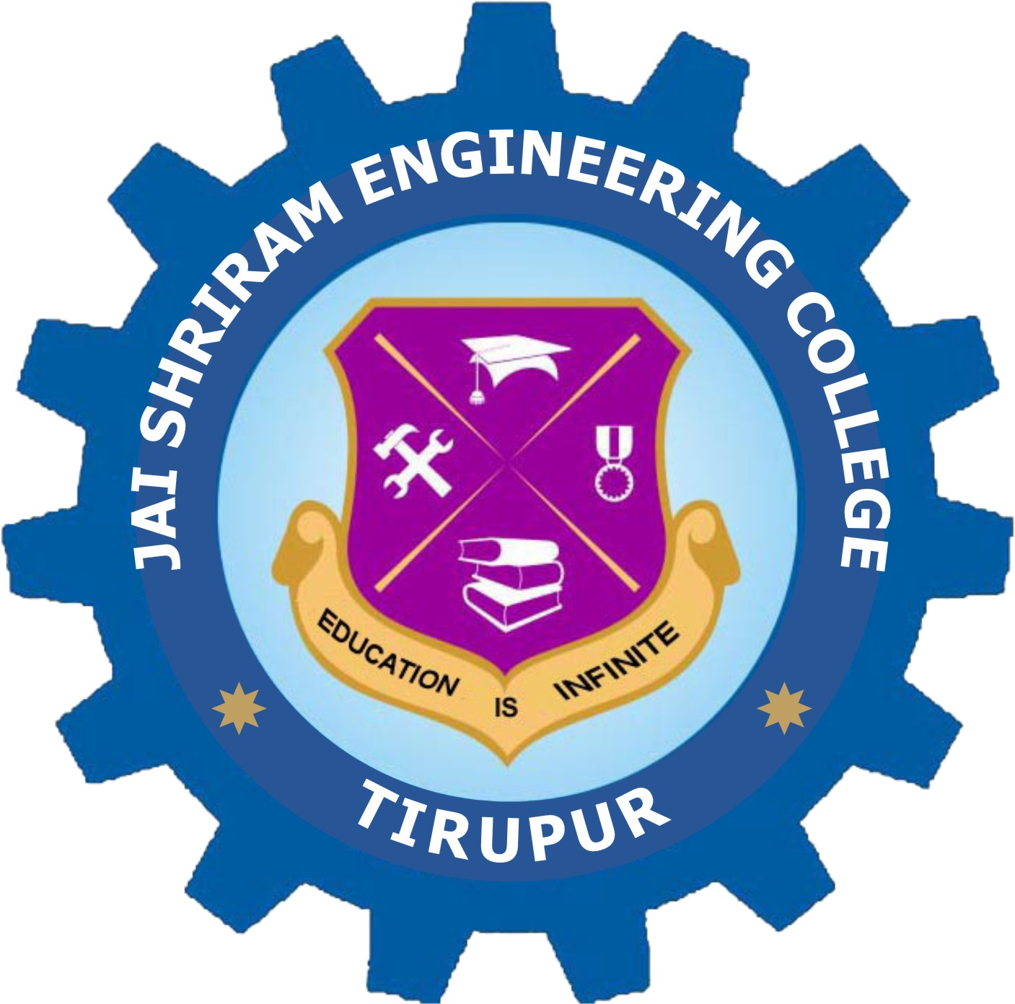
Jai Shriram Engineering College

Post Date: 7th July 2026
College Name: Jai Shriram Engineering College (Autonomous)
College Profile: Jai Shriram Engineering College was established by Shenthil Velavan Trust in the year 2009 with a motive of taking higher education to the village and rural people at all levels of economic platform. The college offers 8 undergraduate and 4 postgraduate programs in Engineering, Technology and Management. JSREC is accredited by NAAC with an A-Grade, two programs are accredited with NBA and JSREC is conferred with autonomous status. The institute’s vision is to promote the rural community students and emphasizes industry-academic interaction by providing students with hands-on training through collaborations with its own industry, Barani Hydraulics group of companies.
Job Title: Assistant Professor, Aptitude trainer, Coding trainer
Department:
- Mechanical Engineering
- English
- Chemistry
- Mathematics

Qualification and Experience:
- Assistant Professor - M.E / M.Tech / NET / SET / Ph.D from reputed institutions with Academic/Industry Experience.
- TPC-Minimum 2 years Academic/Industry Experience.

Profile Requirement:
- Candidate with UG & PG first class in relevant discipline will be preferred for Assistant professor.
- Candidate should have good communication skill
- Commitment towards academic excellence
- Candidates with industrial experience will be also considered

Last Date: Immediate
Pay Scale: Salary as per AICTE Norms
Apply Mode: Email/Post
Interview Process: Personal Interview.
College Website URL: www.jayshriram.edu.in
How to Apply: Interested candidates send their letter of interest and detailed resume both soft copy and hard copy addressed to the Principal of the college.
Email Address: hr@jayshriram.edu.in
Postal Address with Contact Number:
The Principal
Jai Shriram Engineering College
Dharapuram Road, Avinashipalayam
Tirupur District, Tamilnadu
PIN: 638660.
Contact: 0421 - 2313335, 2313336

