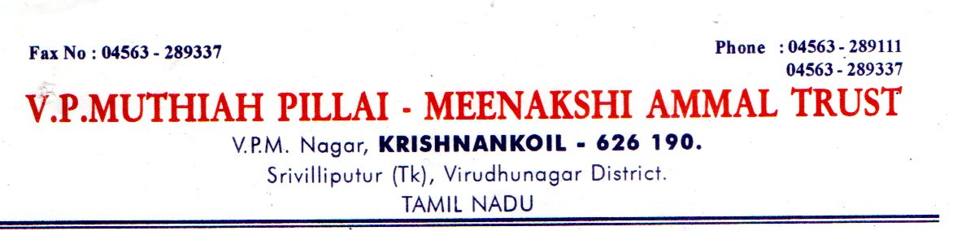
Date: 13.06.2026
Institution Name: VPMM Group of Educational Institutions
Institution Profile: VPMM Group of Educational Institutions, Krishnankoil, Tamil Nadu (www.vpmm.in) boasts of 34 year legacy of producing quality and industry ready graduates. We offer 40 Courses from various Universities.
Salient features of VPMM Group of Educational Institutions:
- Qualified and Experienced faculty members.
- Spacious and well-furnished class rooms, Well – Equipped labs
- English Language Lab to improve communication skills,
- Efficient Clubs-For all around development… YRC, NSS…,
- MoU with Winners Institute of Communicative English, Library a learning resource centre.
- Exposure to Co-curricular and Extra-curricular activities.
- Yoga for peace of mind
- Individual Attention and Caring for each student
Job Title: Principal / Faculty Staff
Department: V.P.M.M. Arts & Science College/ Mathematics / Physics / Chemistry
Qualification: (Principal) PG with M.Sc. , M.A., Ph.D., /(Faculty Staff) PG with Ph.D., or NET,SET Discipline Qualified with First class in all the preceding degrees in the appropriate branch of an exemplary academic record throughout.
Job Title: Principal / Faculty Staff
Department: V.P.M.M. College of Engineering and Technology/CSE/ECE/EEE/Civil/AIDS/AI&ML
Qualification: (Principal) Relevant PG with Ph.D./(Faculty Staff) Relevant PG with Ph.D., or M.E., Discipline Qualified with First class in all the preceding degrees in the appropriate branch of an exemplary academic record throughout

Experience:
Principal - Minimum 20 years Experience
Faculty Staff – Minimum 5 years Experience

Candidate Profile:

- Good Communication Skill
- Self motivator
- Teamwork
- Culture Fit
- Computer Skills

Job Location: Krishnankoil, Srivilliputtur (T.K), Virudhunagar(D.T), Tamil Nadu -626126.
Pay Scale: As per Norms.
Apply Mode: Email
Last Date to Apply: 30.06.2026
College Website: http://www.vpmm.in
How to Apply: Interested candidates should mail their letter of interest with detailed resume (soft copy) with latest passport size photo to vpmminstitutions@gmail.com
Postal Address with Contact No: The Director, VPMM Group of Educational Institutions, Krishnankoil, Srivilliputtur(T.K), Virudhunagar(D.T), Tamil Nadu -626126.
Mobile No: 8925804367

