Director, Recruitment 2026 job notification announced by Kashi Institute of Technology, Mirzamurad, Varanasi, Uttar Pradesh for 2026-2027 academic years. Eligible candidates may apply through Email.
Post Date: 8th of June, 2026
Hiring Organization: Kashi Institute of Technology (NAAC Accredited by Grade “A”)
Organization Profile: Kashi Institute of Technology, established in 2008 in the holy city of Varanasi, is dedicated to shaping future leaders through quality education in engineering and management. The institute is an autonomous, NAAC A-grade accredited institution, approved by AICTE. Over the years, KIT has rapidly advanced in academic excellence, student placements, and has received recognitions such as the Education Excellence Awards.
Job Title/Designation: Director
Qualification & Experience: As per the latest AICTE norms and regulations.
Job Location: Mirzamurad, Varanasi, Uttar Pradesh
Pay Scale: As per Norms
Apply Mode: Email
Organization website: www.kashiit.ac.in
How to Apply: Interested and Eligible candidates request to send their application with a scanned copy of all necessary certificates and passport size photograph to the following Email Address within 15 days after Job posting.
Email Address to Apply: Hr@kashiit.ac.in
Contact Address:
MS 23KM, Varanasi - Prayagraj Rd, Mirzamurd, Varanasi, and Uttar Pradesh -221307

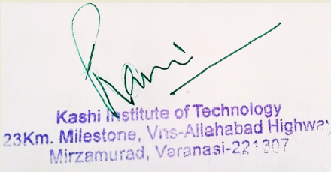
Principal/Authorized Person Signature
with seal

