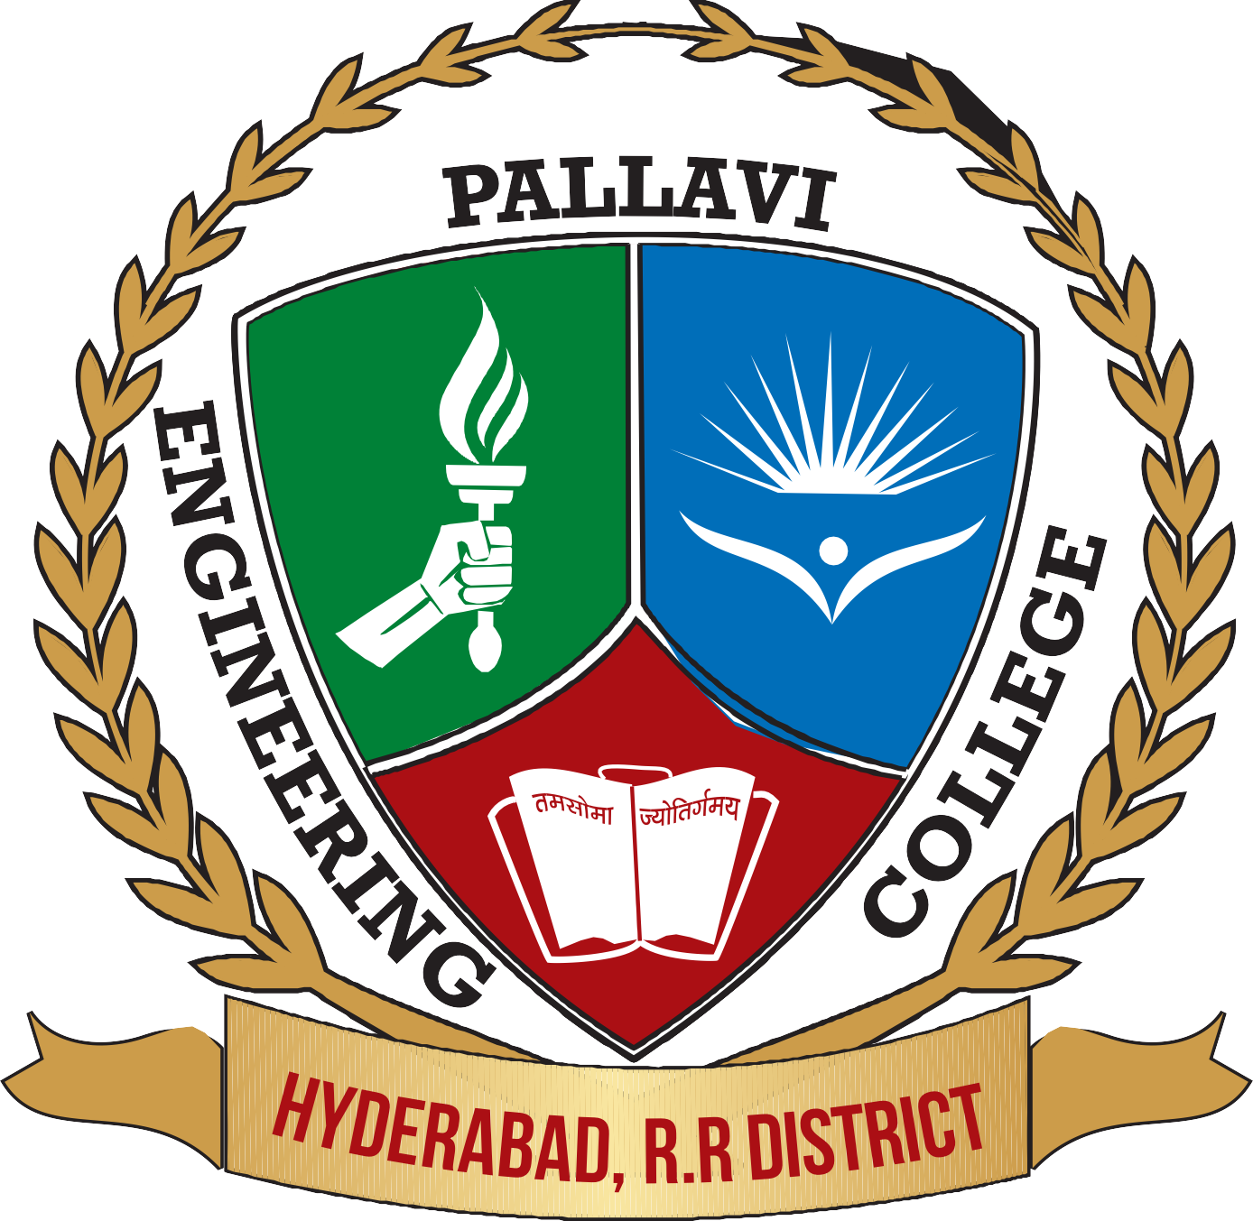
COLLEGE NAME: PALLAVI ENGINEERING COLLEGE

ORGANISATIONAL PROFILE: Pallavi Engineering College (PEC) is promoted and managed under the visionary and dynamic Chairmanship of Sri. Malka Komaraiah Garu supported by the dedicated leadership of Potla shanti Educational Society. The institution was established in 2009 with the objective of serving the educational needs of students with competencies relevant to today’s evolving socio- technical environment. The college is developed strictly in accordance with the rules and regulations of the approving and affiliating bodies, ensuring transparency, discipline, and academic integrity. At PEC, we aspire to build a robust system of quality assurance through continuous evaluation, consistent monitoring, and upgradation of the teaching–learning process to meet global standards. The institution accredited with NBA, NAAC with an ‘A’ grade. PEC is committed to evolving as a Centre of Excellence in Engineering and Technology through innovation, research, and industry collaboration. Pallavi Engineering College received Autonomous status from AICTE, commencing from 2024 academic year.

JOB TITLE: Assistant Professor
DEPARTMENT: Computer Science and Engineering (CSE)
QUALIFICATIONS: B.E/B Tech & M.E/M Tech in Computer Science
Specialization: Artificial Intelligence, Machine Learning.
Job Location: Hayathnagar, Kuntloor Village, Hyderabad

Apply Mode: Careers@pallaviinternationalschool.com
College website URL: https://pallaviengineeringcollege.ac.in

