Institute for future education, entrepreneurship and Leadership (iFEEL), Karla, Lonavla
Notification for Faculty Recruitment 2025

Post Date: 8th April 26
Name of College: Institute for future education, entrepreneurship and Leadership (iFEEL)
Organization Profile: The Institute for Future Education, Entrepreneurship and Leadership (iFEEL) is an AICTE-approved B-school offering industry-focused PGDM programs in Marketing, Finance, HR, and Operations for the past 15 years. Located in Lonavala, iFEEL is dedicated to developing future-ready professionals through innovation, leadership development, and strong industry-academia collaboration. The institute holds prestigious memberships and accreditations, including AACSB, ACBSP, and QAHE, reflecting its global standards.
Job Title/Designation:
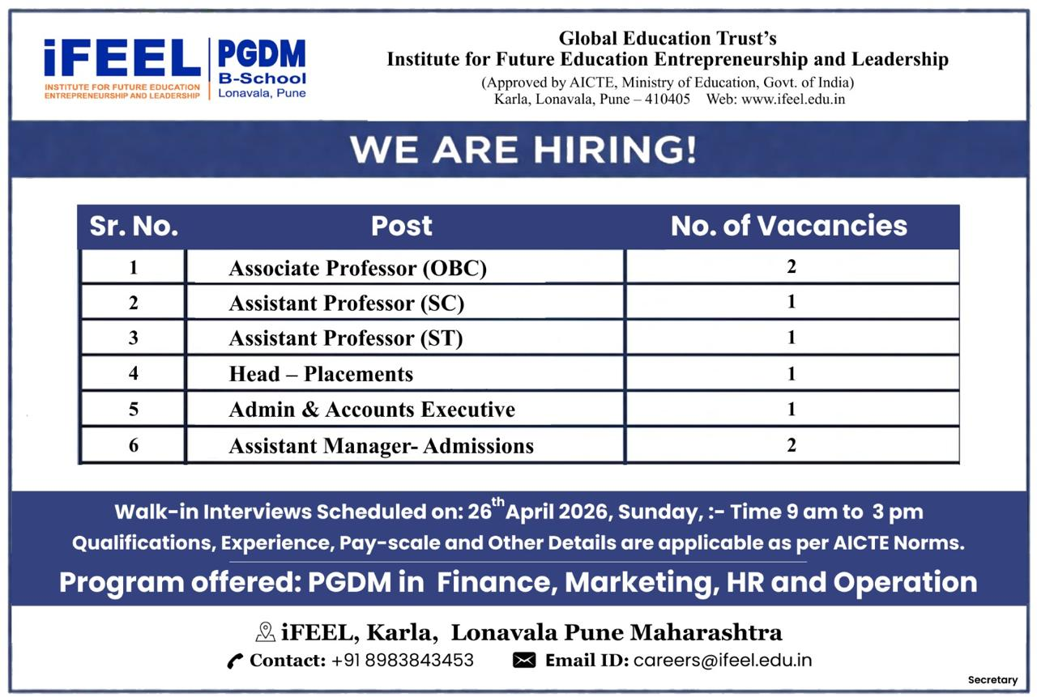
Job Specifications -
Assistant / Associate Professor –
Qualification: Ph.D., Master’s and Bachelor’s Degree with First class in all the preceding degrees in specializations.
Experience:
- Assistant Professor - Minimum 2 Years of Experience
- Associate Professor - Minimum 5 Years of Experience of which 2 years post Ph.D. experience and 7 Research publications
Specialization Required: Operations and Finance.
For TPO -
Qualification: Post Graduate
Experience: Minimum 2–5 years of relevant experience in student placements, corporate connect, training coordination, recruitment support, or institutional industry engagement. Experience in higher education institutions / management institutes / professional colleges will be preferred.
For other administrative positions –
Qualification: Graduate with first class
Experience: 3-5 years of relevant experience in the respective field will be preferred.
Candidate Profile:
Candidates with industry exposure, research acumen, and innovative teaching practices will be given preference
Strong Communication and presentation skills
Experience of handling NBA, NAAC accreditation processes
Job Location: iFEEL B School, Karla, Lonavala, Pune
Pay Scale: As per Norms
Apply Mode: Walk-in and Email
Organization website: www.ifeel.edu.in
Walk-in interviews are scheduled on Sunday, 26th April 26 from 9 am to 3 pm.
Email Address to contact or Apply: careers@ifeel.edu.in
Contact Address: iFEEL, Off Karla Phata, Ekveera Devi Gramasthan Road, Villege – Karla, Taluka, Maval, Pune 410405

Dr. Sagar Bhadange
Deputy Director
iFEEL

