Short Term Course on Agricultural Microbiology Workshop:

Harnessing the power of microbes for sustainable agriculture

Apr 17th to Apr 21st 2023

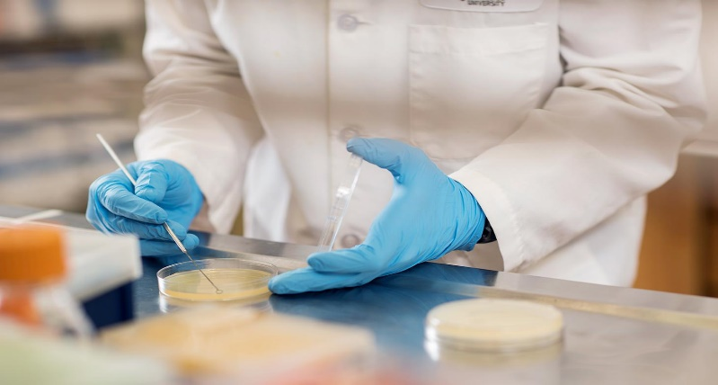
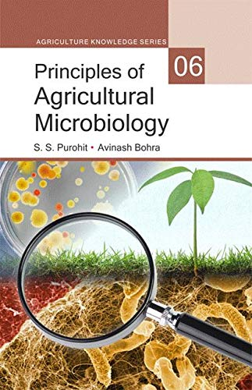

ORGANIZED BY:
DEPARTMENT OF MICROBIOLOGY
SCHOOL OF BIOENGINEERING AND BIOSCIENCES
AND
HUMAN RESOURCE DEVELOPMENT CENTER

LOVELY PROFESSIONAL UNIVERSITY, PUNJAB

BACK DROP AND RATIONALE
This workshop focuses on the crucial role of microbiology in sustainable agriculture. Microbes play a vital role in soil health, nutrient cycling, and plant-microbe interactions, and their manipulation can lead to significant improvements in crop productivity and protection. The review discusses the various beneficial microbes and their functions, such as nitrogen-fixing bacteria, phosphate-solubilizing fungi, and plant growth-promoting rhizobacteria, and their application in agriculture. Additionally, the review highlights the potential of microbiome engineering for crop protection and discusses microbial biocontrol agents as an eco-friendly alternative to chemical pesticides. Overall, this workshop highlights the importance of harnessing the power of microbiology to promote sustainable agriculture and meet the challenges of food security and environmental sustainability.

LEARNING OUTCOMES
This workshop aims to provide participants with the following outcomes

Understanding the role of microbes in soil health and plant growth.

Identification and isolation of beneficial microbial strains for use in agriculture.

Techniques for the application of microbes in agriculture, including inoculants and biofertilizers.

Methods for measuring and evaluating the efficacy of microbial products in the field.

Knowledge of the regulatory framework governing the use of microbial products in agriculture.
- Discussions on the future of microbial-based solutions for sustainable agriculture

WHO CAN ATTEND?
The workshop suits students, researchers, and professionals in microbiology, agriculture, environmental science, and biotechnology.

No prior knowledge of agricultural microbiology is necessary, but a basic understanding of microbiology and agriculture would be beneficial.

PEDAGOGY
The Professional Development Workshop will include both Lectures, Discussions, and quizzes.

WORKSHOP PREREQUISITES
- None

RESOURCE PERSON
Arun Karnwal is a Professor at the Department of Microbiology, School of Bioengineering & Biosciences, Lovely Professional University, Phagwara, Punjab, India. He completed his Ph. D. in Microbiology at Gurukul Kangri University, India. His research interest is in isolating bacterial strains, biochemical characterization and effect of different parameters on growth on bacterial cultures, characterization for PGPR (plant growth promoting) activity, Identification and quantification of phytohormones, the Gnotobiotic assay to check phytohormones production and growth promotion activity in rice. Greenhouse assay to check growth promotion activity, Increase grain yield by applying biological control agent, biofertilizer, co-inoculation of biocontrol, and biofertilizer.

WORKSHOP SCHEDULE: 06:30-08:30 PM

Day | Date | Topics
Day 1 | 17-04-2023 | Introduction to Agricultural Microbiology  · Definition and scope of agricultural microbiology  · Importance of microorganisms in agriculture  · Historical overview of agricultural microbiology  Soil Microbiology  · Soil as a microbial habitat  · Microbial diversity in soil  · Roles of microorganisms in soil processes (e.g., nutrient cycling, soil structure, plant-microbe interactions)
Day 2 | 18-04-2023 | Plant-Microbe Interactions  · Types of plant-microbe interactions (e.g., symbiosis, pathogenesis)  · Beneficial plant-microbe interactions and their applications in agriculture (e.g., plant growth promotion, biocontrol)
Day 3 | 19-04-2023 | Microbial Biotechnology for Sustainable Agriculture  · Genetic engineering of microbes for agricultural applications (e.g., biofertilizers, bioremediation)  · Commercial applications of microbial biotechnology in agriculture
Day 4 | 20-04-2023 | Microbial Ecology and the Environment  · Microbial community dynamics and interactions  · Microbial responses to environmental stressors (e.g., climate change, pollutants)  · Role of microbial ecology in promoting environmental sustainability
Day 5 | 21-04-2023 | Discussion and Future Directions  · Group discussion on potential future directions in agricultural microbiology research and applications  · Reflection on the workshop content and how to apply it to participants' own work

IMPORTANT DATES AND REGISTRATION FEE

Participant Type | Registration  Fee per participant | Registration Closes
LPU Associate: Research Scholar /  Faculty / Alumni | Rs. 1200/-
External Participants
Note: Fee once paid is non-refundable.
Prof. (Dr.) Sunaina Ahuja,
Dean and Head-Human
Resource Development Centre,
LPU

HOW TO REGISTER
Step 1: Go to https://www.lpu.in/HRD/
Step 2: Sign up as a new user-As a New user enter your particulars to Register/ Create an Account
Step 3: For Course Details click on “View brochure” in the “Courses available” Tab.
Step 4: Login to your Account created at the time of Registration. If already registered, you can directly Login and access your account.
Step 5: Click on “Register” to register for the desired course available on the Home page.
Step 6: Select the Payment mode and make payment accordingly.
Mr. Puneet Soni, Sr. Officer,
Human Resource Development Center, LPU

CERTIFICATION
E-certificates will be awarded to the participants on meeting the eligibility criteria i.e. 100% attendance and 50% Score in Post Training Evaluation.

ORGANIZING TEAM

COURSE CONVENER
Prof. (Dr.) Neeta Raj Sharma,
Sr. Dean and HOS, School of Bioengineering & Biosciences,
LPU
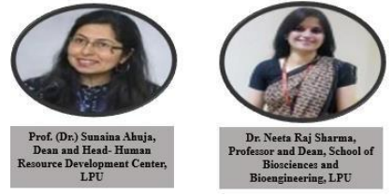
COURSE COORDINATOR
Prof. Umesh Goutam, School of Bioengineering & Biosciences. LPU
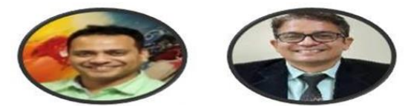

ABOUT THE HOST INSTITUTION
Lovely Professional University is ranked 36th amongst top universities in India and listed among the 1001-1200 universities in the world by the prestigious The World University Rankings 2022. As per the Times Higher Education Impact Ranking 2022, LPU is ranked 74th amongst Global Institutions. This success is achieved by the unmatchable ability of the university in ensuring inclusive and equitable quality education and promoting lifelong learning opportunities to all, providing inclusive and

sustainable economic growth, strengthening the means of implementation and revitalizing the global partnership for sustainable development. LPU ranks 62nd amongst all government and private universities in India as per NIRF Ranking 2021. An eco-friendly, high-tech campus sprawling along the National Highway at the entry of Jalandhar City, welcomes you. The University is acclaimed for academic excellence and multidisciplinary program offerings. The University takes was ranked 3rd in India in the Atal Ranking of Institutions on Innovation Achievements (ARIIA). Every year thousands of students are mentored to emerge as global citizens and seasoned professionals, as a result of the curriculum, pedagogy, evaluation schemes and holistic development initiatives adopted at the University.
LPU-Human Resource Development Center (LPU-HRDC) is mandated with the charge of Faculty Development and Outreach Training. HRDC engages with the maestros in industry and academia to ensure capacity building for developing industry ready professionals. Outreach Training Programs organized by LPU-HRDC focus on core competence development, experiential learning approaches, and developing sustainable systems. LPU- HRDC hosts the local chapter of SWAYAM – NPTEL offering Massive Open Online Courses in all disciplines.
School of Bioengineering and Biosciences was introduced at Lovely Profes- sional University in the year 2006. The school has now created a competi- tive and research friendly environment, with its infrastructure and facilities. The school has eight domains namely: Biotechnology, Biochemistry, Mi- crobiology, Molecular Biology & Genetic Engineering, Botany, Zoology, Bioinformatics and Forensic Science. The school focuses mainly on the quality of education offered to the students and hence has recruited highly competent faculty from educational, industrial and regulatory back ground. The activities of the school enthralling around to develop the acumen to ap- ply the findings of biological sciences for the benefit of community, which are being recognized at various national & international platforms. The re- search outcome can be viewed in terms of publications in peer reviewed journals national patents

In case of any query, contact:
Mr. Puneet Soni, Senior Officer, Human Resource Development Center Email: academic_staffcollege@lpu.co.in
Contact No: +91-98157-40212

Dr. Umesh Gautam, Professor and Head, Department of Molecular Biology and Genetic Engineering, School of Biosciences and Bioengineering, Lovely Professional University. Contact No: +91-76966-60630

