IMPORTANT DATES

Submission of Registration form | 15.10.2022
Acceptance Notification | 16.10.2022
REGISTER YOUR DETAILS

https://forms.gle/XYfob4jn5MCBpgh79

REGISTRATION FEE

- External Faculty / Research Scholars – Rs. 500 (Including GST)
- Internal Faculty - Rs. 250 (Including GST)
Payment Link: https://vitchennaievents.com/conf1/

RESOURCE PERSONS

- Dr. Ferdin Joe John Joseph, Asst. Dean Research and Academic Affairs, Thai-Nichi Institute of Technology, Thailand
- Dr. Sundarabalan, Scientist, NASA(GSS), USA
- Dr. A. Kannan, Senior Professor, VIT Vellore
[Rtd. Professor, Dept. of IST, CEG Campus, Anna University, Chennai]
- Dr. Manjula D, Professor VIT Chennai.
[Rtd. Professor, Dept. of CSE, CEG Campus, Anna University, Chennai]
- Dr. S. Geetha, Associate Dean (Research), VIT Chennai
- Dr. Jagadeesh Kannan R, Professor, VIT Chennai
- Dr. T. S. Pradeep Kumar, Professor VIT Chennai
- Dr. Jeya Mala D, Associate Professor Senior, VIT Chennai.
- Dr. Preeth, Assistant Professor, IIITDM, Kancheepuram.
- Dr.S.Ganapathy, Associate Professor, VIT Chennai.
- Dr.V. Muthumanikandan, Asst. Prof. (Sr. Gr-2), VIT Chennai.

ADDRESS FOR COMMUNICATION

Dr. Ganapathy S, Associate Professor,
(Listed in Top 2% Scientists in the world)
Centre for Cyber Physical Systems & School of Computer Science and Engineering,
Vellore Institute of Technology Chennai - 600 127.
Email: sganapathy@vit.ac.in, 9488869712

Dr. V.Muthumanikandan, Assistant Professor (Sr.Gr. II),
School of Computer Science & Engineering
Vellore Institute of Technology Chennai - 600 127.
Email: muthumanikandan.v@vit.ac.in, 9629574328

ABOUT THE FDP

The focus is on the often-challenging act of sifting through vast amounts of data in search of knowledge that could help businesses make informed decisions about their operations, such as occult patterns, correlations, market trends, and client preferences. Computers and systems can conduct actions or make recommendations based on the information they can gather from digital images, movies, and other visual inputs thanks to artificial intelligence of computer vision. CPS can be characterised as integration across industrial domains, lifecycles, and technologies, as well as "smartness," including a technical focus, cross-cutting considerations, the level of automation, and life-cycle integration. The scope of the FDP covers talks on different contemporary fields and lists both the funding opportunities as well as obstacles for further research.

FDP SESSION TOPICS

- Data Analytics
- Image and Computer Vision
- Cyber Physical Systems
- Artificial Intelligence
- Network and Security

WHO SHALL PARTICIPATE?

Academic Professionals and Research Scholars, who are working as/doing a full time Faculty/Research shall attend - who are interested in sharing their thoughts and learning from experts.

 A Five-Day Online Faculty Development Programme (FDP)

On

Research & Funding Opportunities in Computer Science (ReFOCUS)

17th October 2022 to 21th October 2022

Coordinators

Dr. Ganapathy S.
Dr. Muthumanikandan V.

Organized by

Centre for Cyber Physical System, Network Security Research Group & School of Computer Science & Engineering

VIT Chennai

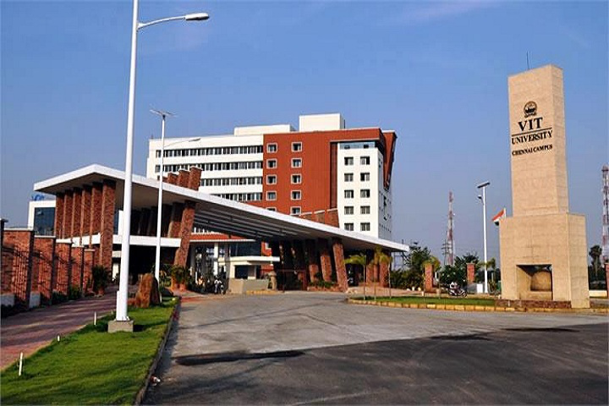

VIT - A place to learn; A chance to grow

ABOUT VIT

VIT has made a mark in the field of higher education in India by providing quality education on par with institutions of international standards, through its 38 years of existence in a cross-cultural ambience with extensive application-oriented research. VIT was founded in 1984 by Dr. G. Viswanathan, a former parliamentarian and Minister in the Tamil Nadu Government, as a self-financing institution called Vellore Engineering College. Since then, the institution has grown from strength to strength. Conferred upon the status of Deemed to be university in 2001 by MHRD, VIT currently offers UG, PG and Research programmes on its four campuses at Vellore, Chennai, Bhopal and Amaravati. VIT Chennai is a globally engaged, competitive, comprehensive and research-enriched university campus strategically positioned in the capital city of Tamil Nadu, to respond to major industrial, social, economic and environmental demands and challenges. VIT Chennai is ably spearheaded by the Vice Presidents Mr. Sankar Viswanathan, Dr. Sekar Viswanathan, Mr. G.V. Selvam and Ms. Kadhambari S. Viswanathan, Assistant Vice President, Dr. Rambabu Kodali, Vice Chancellor and Dr. V. S. Kanchana Bhaaskaran, Pro-Vice Chancellor of VIT Chennai.

The focus of the university is:
- To maximize the Industrial connectivity
- To create Centres of Excellence in contemporary areas of research
- To enrich Technological and Managerial Human Capital nurtured in a multicultural ambience
- To provide a common platform for the agglomeration of ideas of personnel from various walks of life for learning enrichment
- To create opportunities and exploit the available resources to benefit industry / society
- To encourage participation in the National Agenda of knowledge building
- To foster International collaborations for mutual benefits in areas of research

ABOUT VIT CHENNAI

VIT Chennai was established in 2010. VIT was established with the aim of providing quality higher education on par with international standards. It persistently seeks and adopts innovative methods to improve the quality of higher education on a consistent basis. The campus has a cosmopolitan atmosphere with students from all corners of the globe. Experienced and learned teachers are strongly encouraged to nurture the students. Our Memoranda of Understanding with various international universities are our major strength. They provide for an exchange of students and faculty and encourage joint research projects for the mutual benefit of these universities.

ABOUT SCOPE

The School of Computer Science and Engineering (SCOPE) at Vellore Institute of Technology was established for imparting state-of-the-art education, training and research in the field of Computer Science and allied areas through its UG, PG and Ph.D. Programmes.
- B.Tech. Computer Science & Engineering (4 years)
- B.Tech. Computer Science and Engineering with Specialisation in Artificial Intelligence and Machine Learning
- B.Tech. Computer Science and Engineering with Specialisation in Cyber Physical Systems
- B.Tech. Computer Science and Engineering with Specialisation in Artificial Intelligence and Robotics
- M.Tech. Software Engineering (a 5-Year Integrated Programme)
- M.Tech. Computer Science and Engineering with Specialisation in Business Analytics (a 5-year integrated programme)
- M.Tech. Computer Science and Engineering with Specialisation in Artificial Intelligence and Machine Learning (in collaboration with C-DAC, Pune)
- M.Tech. Computer Science and Engineering with Specialisation in Cyber-Physical Systems (in collaboration with C-DAC, Pune)
- M.Tech. Computer Science and Engineering (2 years)
- M.Tech. CSE with Specialisation in Big Data Analytics (2 years)
- Master of Computer Applications(2 years)
- Ph.D. Programmes in the domain of Computer Science and Engineering.

VISION & MISSION OF SCOPE
Vision
- To be a world-renowned centre of education, research and service in computing and allied domains

Mission
- To offer computing education programs with the goal that the students become technically competent and develop lifelong learning skills
- To undertake path-breaking research that creates new computing technologies and solutions for industry and society at large
- To foster vibrant outreach programs for industry, research organizations, academia and society

